What Sound Editors Need from Picture Editors (besides love!)
by Victoria Sampson – Writer/Director/Film and Sound Editor vsampson@aol.com

1. Good sound! Hire a professional. Don’t rely on cousin Billy.

2. Investigate multiple microphones. Import ALL the mics into your edit session.

3. Know what your final export needs to be and work backwards.

4. Put Academy Standard Leaders on the head of each reel (or short form project) and at the tail.

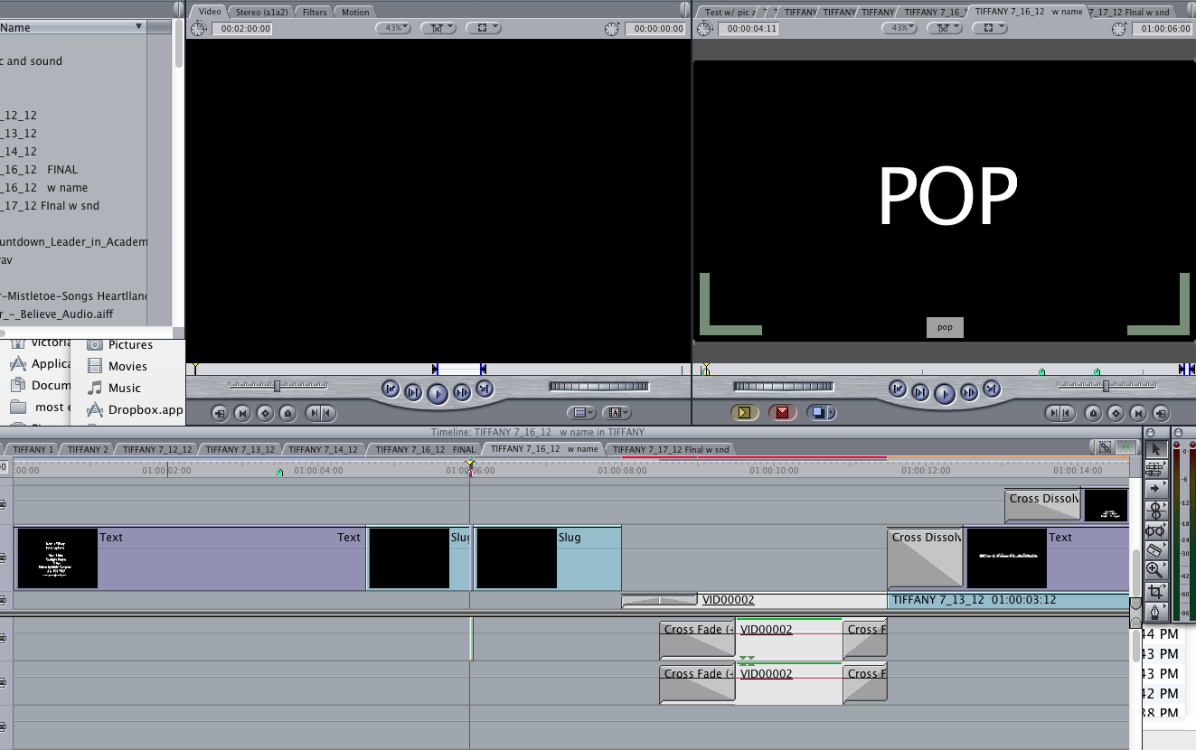

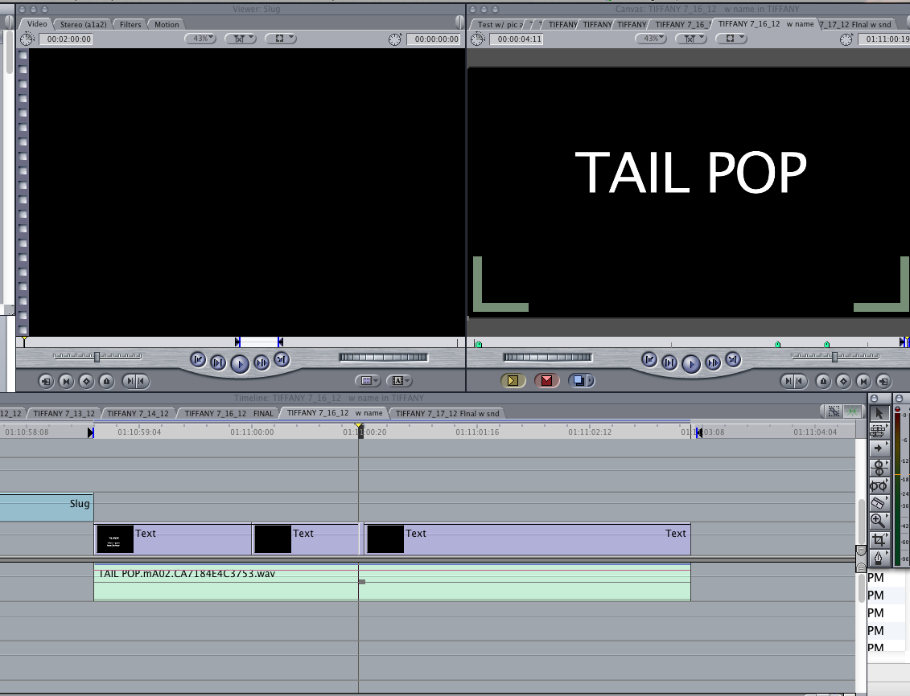

Here are some Academy Standard leaders that I created that you can download from Youtube:

http://youtu.be/a37snzrbGN4 (head leader with pop 24 fps)

http://youtu.be/8zcbrggJvwI (tail leader w/ pop 24 fps)

5. Put a burned-in timecode in the black (not over image) generated from the 000 start mark of an Academy Standard Leader.

6. Break your feature length project into 15-20 minute “reels” putting Academy Leader on the head and tail of each reel. Do not put any music cues bridging across reels. Timecode hour should match reel number. Reel 1 would be 01:00:00:00 timecode. Reel 2 would be 02:00:00:00 etc.

7. When exporting your session as an OMF, check the boxes for “include levels” and “crossfade transitions.” Check with your sound company/person to see if they want 16 bit or 24 bit. 24 is preferable as is 48K.
If you’re NOT giving the sound editor all of the production audio files, then put at least 10 second handles as part of your OMF choices. If you are giving them the production audio, then two seconds is fine.
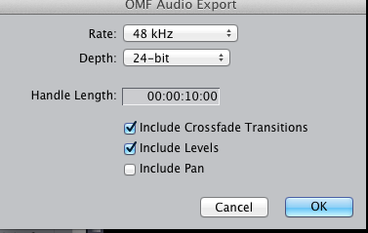

8. Export a Quicktime for each reel and label it as “NAME_Reel_vDATE_QT or OMF or GT (guide track) for example:
IBE (stands for the name of the film In Between Engagements)_R1_v07_24_12_QT

The version date should match your final locked picture. If you make any changes after you’ve turned over this version to your sound editor, then you need to make new quicktimes and new OMFs and new Guide Tracks with the NEW date.

9. Before exporting the OMF, put all your production audio on the first tracks, followed by sound effects on their own tracks, followed by music. Do not mix production audio with sound effects or music. Keep them on separate tracks.

10. Export a Guide Track of all the production audio only. (No SFX or MX) (Export as an AIFF file)

11. Export the quicktimes for each reel with all the sound. (We later import the audio from the quicktime to use as another guide – to see what the director’s idea of where music will be and how loud and where SFX are etc.)

12. Make sure that your quicktime and OMF session’s frame rates are the same.

13. Ask your sound editor for any sound effects that you want to use while you’re still in the editing process. The director will get used to their sound and will make it a lot easier for refining later. (Temp love)

14. Give your sound editor:
A. A copy of a lined script (if there is one)
B. Copy of the sound reports from the production mixer
C. A complete copy of ALL the original production audio files in a folder labeled PRODUCTION AUDIO (including any wild tracks or VO tracks shot during the production)
D. A list of the cast with their character names and real names.
E. A list of all the LFOAs. (Last frame of action) for each reel.
F. What the delivery requirements are sound-wise. (Will there be a need for a 5.1 surround mix? A LR stereo mix? A foreign mix (music and effects only) A TV/Airline version?
G. A CONTINUITY – a list of what scenes are in what reels – with a brief description of each scene.
H. A post production schedule, if there is one.
I. Contact information for the key players – director, film editor, assistant film editor, composer etc.
J. Lots of love! And food. And sleep time.

15. Be willing to listen to new dialogue, sound effects. We, as sound editors, are trying our best to make your film sound professional and we often may find a substitute line of dialogue to help fix a problem.

16. Trust your sound editor. And be available to come listen to playbacks. Better to adjust things in the editing room than on the high-priced dub stage.

17. Set aside enough of a budget for sound. We sound editors often work WAY too many hours trying to fix problems that could have been fixed on the set. We usually work on the sound of an independent feature film for an average of 6 to 8 weeks for a dialogue driven movie and up to 3 months on an action/adventure film. We cannot pay our bills with “but everyone on the shoot worked for free!”

18. For those of you who are directors, please refer to the hand-out “An Open Letter From Your Sound Department”

LET’S MAKE GREAT MOVIES SOUND GREAT!!

